SPECIALTIES WORKING KNOWLEDGE

• Interface Design • HTML 5

• User Experience Design • CSS 3

• Interaction Design • Terminal

• Project Management • Sublime Text

• Style Boarding • Design In-Browser

• Building Iconic Languages • Axure

• Story Boarding • Word

• Proto Typing • PowerPoint

• Icon Design

• Logo Design

• Illustration

• Character Design

• Animation

• Typography

SOFTWARE EXPERIENCE FRONT-END DEV

• Adobe CS 6: • Yeoman/Bower/Grunt

• Fireworks • SASS/Compass

• Illustrator • Bootstrap

• PhotoShop • JavaScript/JQuery

• InDesign • SVG

• Dreamweaver • Font Awesome

• Sketch •  Angular

• Affinity Designer •  Ruby On Rails

• Pixelmator •  WordPress

PROFILE

Art Director in the late ’80s in Miami. In 1993 moved to London, England and worked at top ten Advertising agency TBWA (Omnicom). In the late 90s I transitioned to ‘Multimedia’, web and UI design. I freelanced in the early 2000s, now full-time UI/UX Design & Front End Dev.

Guru-level with all Adobe Creative Suite, Sketch. Axure wireframing, though often straight to Bootstrap design in-browser. Love reducing complexity into simplicity, when designed well the user interface seems inevitable. I stick to the brief and as work rapidly. I enjoy work. For coding I use Sublime Text and the Command Line.

Last job: Civic Inc, UI/UX Design for Nashville Metro internal and external websites. Tackling complex government UI/UX challenges: Permit Systems, Land Management, Bridge Admin, Funds Management. Reducing many pages into simple navigable interfaces and presenting complex data in a easily digestible manner.

Prior work, JPay, unusual clientele: Inmates and their friends & famILY. I designed for a captive audience! It's challenging to make simple UX for low-literacy customers. I created, produced and admin’d all JPay projects’ UI single-handed (some print work). So whether it’s an entire website, wireframes, theming, interactive PDF, new app UI, skin job, a set of icons, a few more buttons I can deliver. I'm a coder groupie :) Motto: Don’t let ‘design’ get in the way of communication.

PROFESSIONAL EXPERIENCE

UI/UX Designer, Civic Inc, Nashville, TN

09/2013 – 02/2015

Civic Inc UI/UX DESIGNER, FRONT-END DEV

* Green Field UI/UX Design for Govt Service Systems
* Rapid prototyping of design and interaction concepts for evaluation by senior management and other stakeholders
* Create wireframes, sitemaps, interaction flows, and prototypes for desktop and online applications.
* Create interactive prototypes
* Nashville Metro projects listed:
  + - Building Permits System
    - Bridge Administration
    - Funds Management
    - Land Management
    - Storm Grates Mobile App
    - Bikeways site
* Skills & Tech:
  + - UI/UX Design
    - Mobile/Responsive
    - Icon languages
    - Guru level Adobe CS Suite, Sketch, Affinity Designer
    - Front End Coding, Sublime Text, Command Line, Git
    - HTML/CSS/SASS/Compass, Yo/Bower/Grunt, SVG/Font Awesome

PROFESSIONAL EXPERIENCE continued…

UI/UX Designer, JPay, Miami, FL 2008 – 09/2013

JPAY.COM UI/UX DESIGNER, FRONT-END DEV

* Participate in user research
* Analytics research
* Participate in research analysis and synthesis as well as identification and prioritization of functional requirements.
* Create wireframes, sitemaps, interaction flows, and prototypes for desktop and online applications.
* Create interactive prototypes
* Participate in user testing throughout the design and development process.
* Develop User persona, User Profile
* HTML/CSS
* Rapid prototyping of design and interaction concepts for evaluation by senior management and other stakeholders
* Creating UI assets and managing their delivery to the development team
* Producing detailed UI design specifications as required by the development team - Contributing to UI QA during development
* Created hundreds of icons

JPAY MOBILE APP, UI/UX DESIGN

* Created Interactive Prototypes
* Worked with team of engineers
* Rapid prototyping of design and interaction concepts for evaluation by senior management and other stakeholders
* Designing polished UIs for multiple application platforms and mobile web specifications
* Creating UI assets and managing their delivery to the development team
* Producing detailed UI design specifications as required by the development team - Contributing to UI QA during development

JP4 MINI-TABLET DEVICE, UI/UX DESIGN

* Created Interactive Prototypes
* Worked with team of engineers
* Rapid prototyping of design and interaction concepts for evaluation by senior management and other stakeholders
* Creating UI assets and managing their delivery to the development team
* Producing detailed UI design specifications as required by the development team - Contributing to UI QA during development

JP3 UI, SMALL MP3 PLAYER, UI/UX DESIGN

* Created Interactive Prototypes
* Worked with team of engineers

JPAYINC.COM, UI/UX DESIGN, FRONT-END DEV

* HTML/CSS
* Responsive design
* Hand-coded site

PROFESSIONAL EXPERIENCE continued…

JPAY EMAIL MARKETING, UI/UX DESIGN

* HTML4 tables(!) and inline CSS
* Responsive design
* Hand-coded site

MLOTTO APP UI-LOTTO APP (SIDE PROJECT FOR JPAY), UI/UX DESIGN

* Created Interactive Prototypes
* Gameplay Design

MLOTTO.COM WEBSITE, UI/UX DESIGN AND FRONT-END DEV

* HTML5/CSS3
* JavaScript
* Hand-coded site

Print work

* Designing marketing and advertising material for mobile and web, including third-party and affiliate applications and sites
* Corporate Branding
* Advertising
* Collateral
* Stationary
* Design
* Production

PrisonRide.com

* UI/UX Design (site never completed)

UI/UX Designer, Front-End Dev, Safari Ltd, 2007 – 2008, Miami, FL

* UI/UX Design
* HTML/CSS
* Adobe Creative Suite, All

Designer, Planning Group Int (now SapientNitro), Miami, 2006

* UI/UX Design
* HTML/CSS
* Flash
* Adobe Creative Suite, All
* Print

UI/UX Designer, Diaz & Cooper Adv, Miami, FL, 2003 – 2006,

* UI/UX Design
* HTML/CSS
* Flash
* Print
* Adobe Creative Suite, All

PROFESSIONAL EXPERIENCE continued…

Art Director & ‘Multimedia designer’, TBWA, 1998 – 2000, London, England

* UI/UX Design
* HTML/CSS
* Macromedia Director
* Adobe Creative Suite, All
* QuarkXpress

Art Director, Freelance, 1993 – 1997, Miami, FL

* Adobe Creative Suite, All
* QuarkXpress

Art Director/Production, Tinsley Adv, 1990 – 1993, Miami, FL,

* Adobe Creative Suite, All
* Quark Xpress

EDUCATION

International Fine Arts College, 1987, Miami, FL Associates Degree

Trent College, 1984, Long Eaton, UK

Attended ‘Public’ school in England, received Art Scholarship. Played Rugby for my county.

REFERRALS

Joanna Perry, Creative Director, joanna@nomadhome.net, +44 788-418-7100

Mike Mack, Coder, mmack@sig.org, (415) 509-1909

Don Pham, Project Manager, don.kim.pham@gmail, (954) 801-9975

> SEE PORTFOLIO BELOW >

PORTFOLIO

Civic Inc, Bridge Admin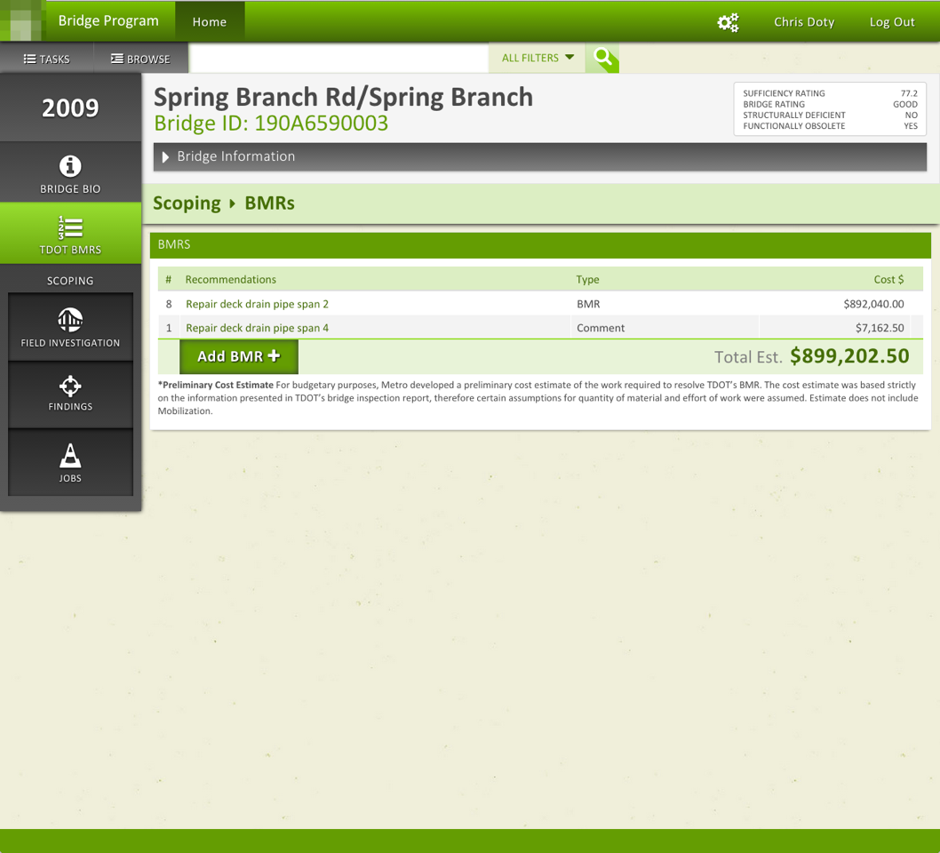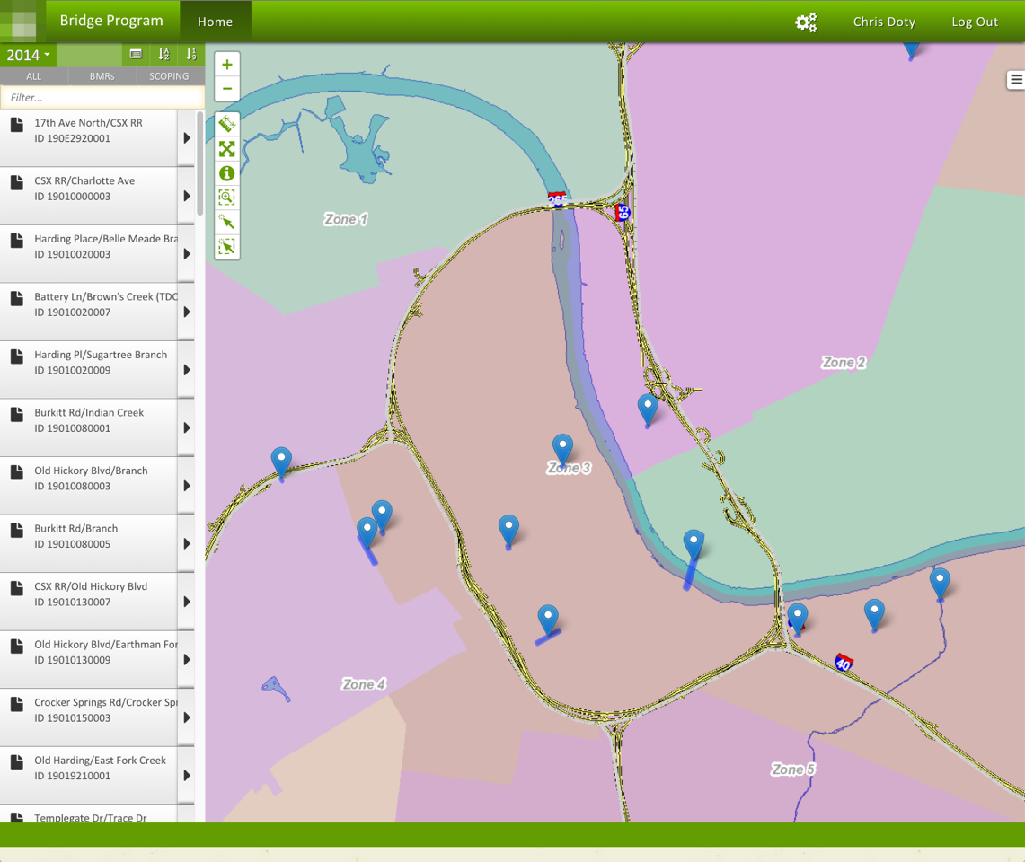

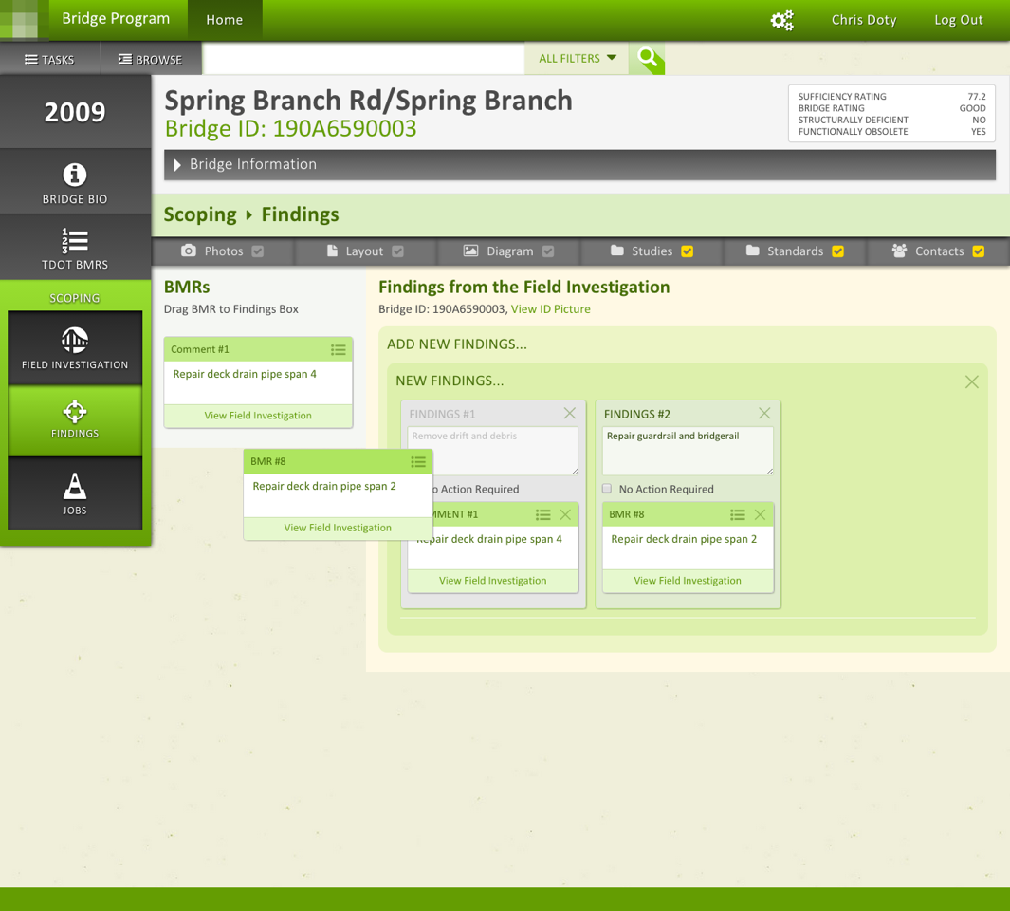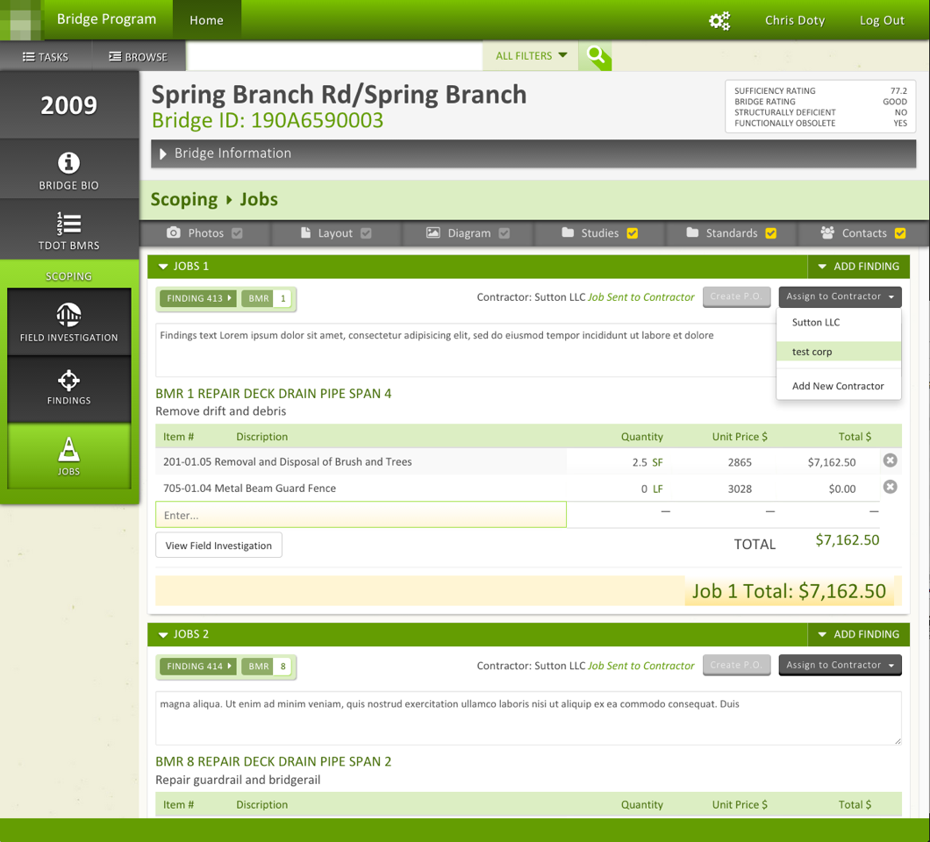

Civic Inc, Bridge Admin

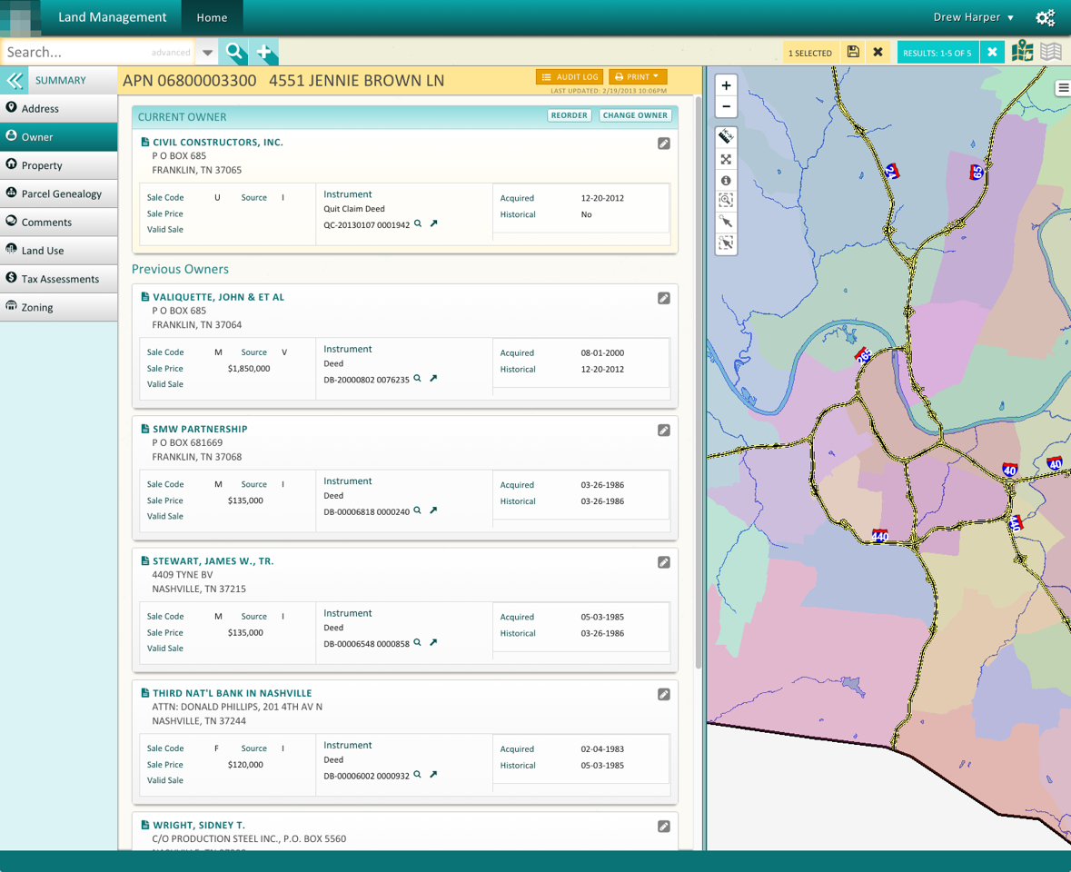

Civic Inc, Land Management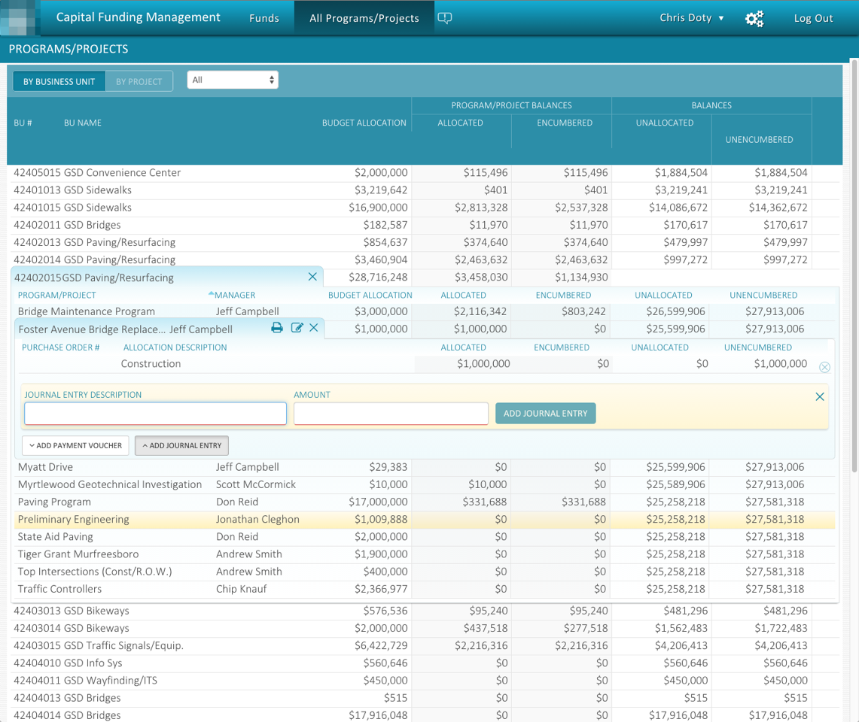

Civic Inc, City Funding

Civic Inc, Permits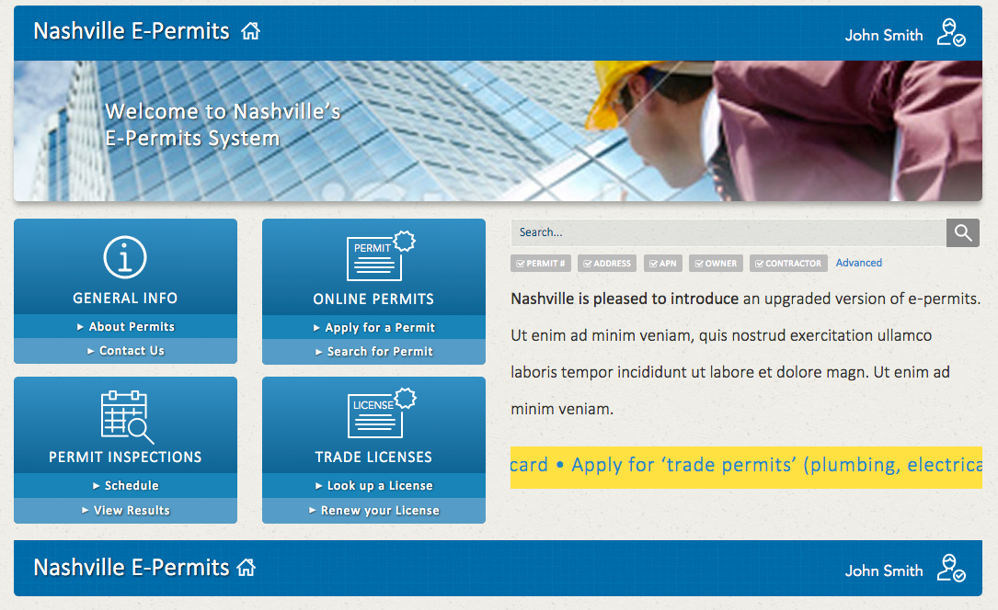

Civic Inc Bikeways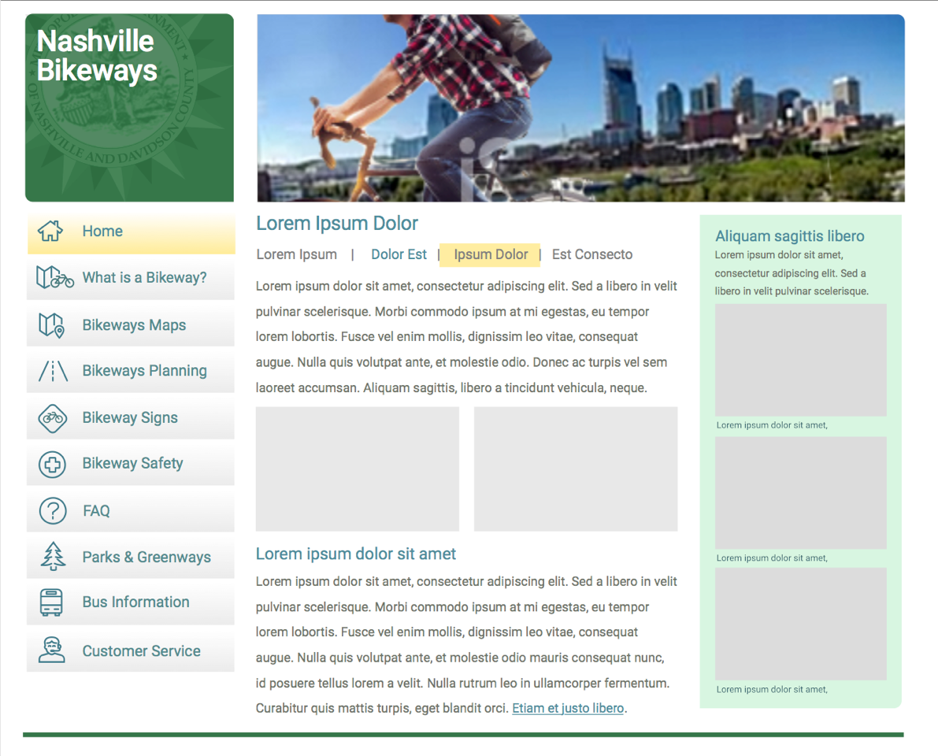

JPay.com website

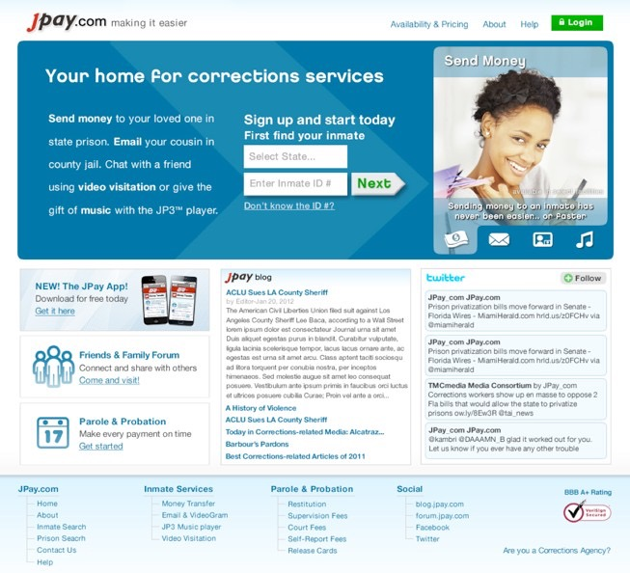

JPay.com website

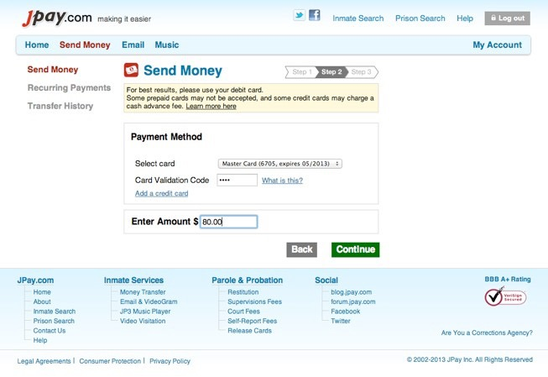

JP4 UI for mini-tablet (for inmates)

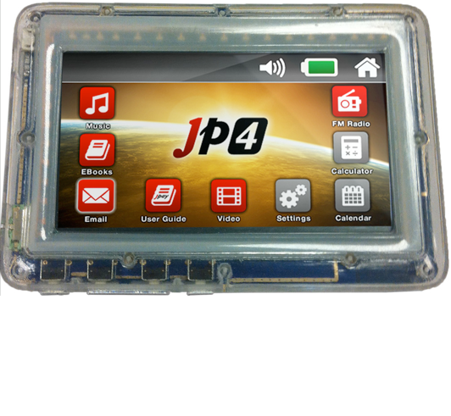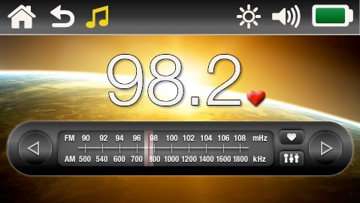

JP4 Radio UI

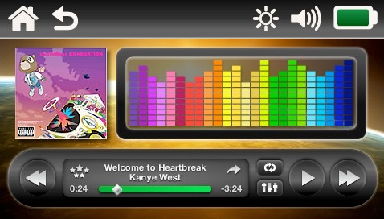

JP4 Music Player

JPay’s JP4

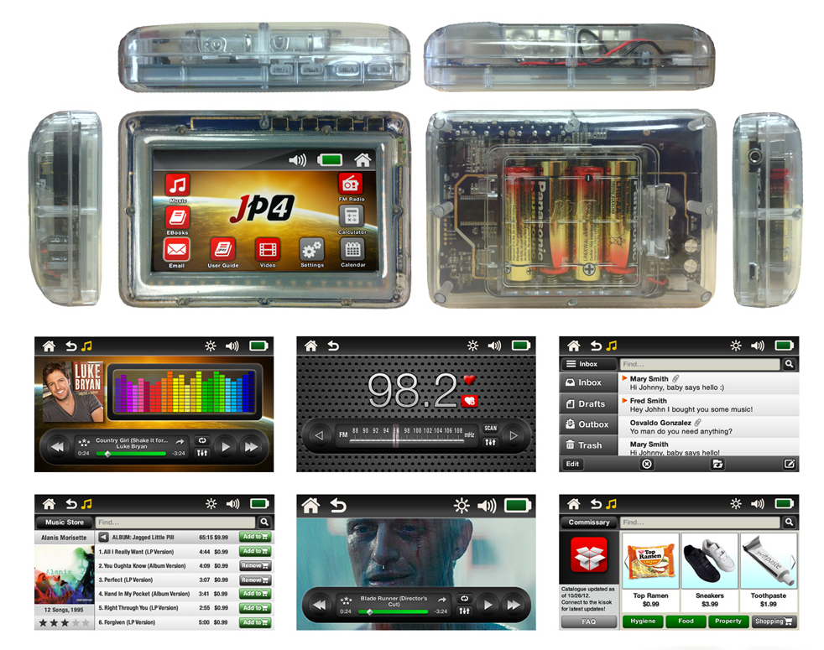

JP4 App

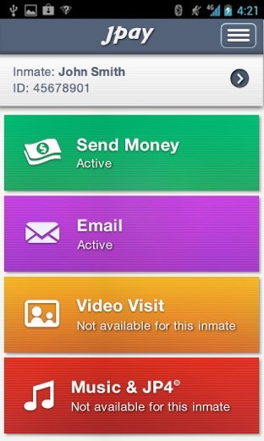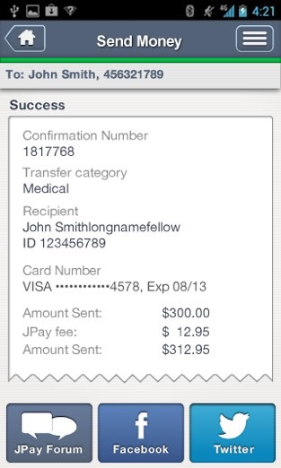

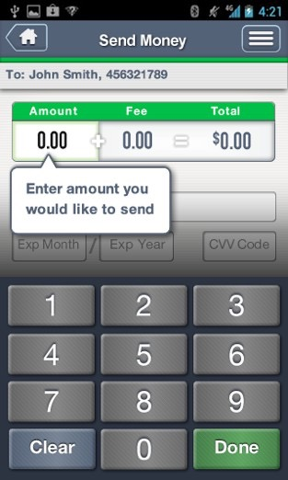 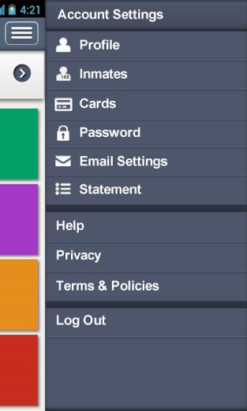

JP4 App – EMail

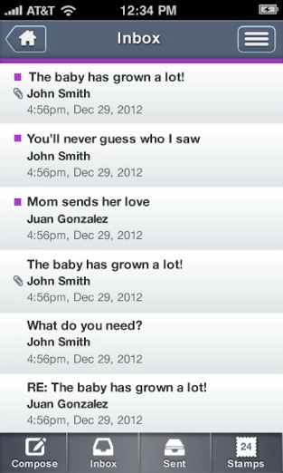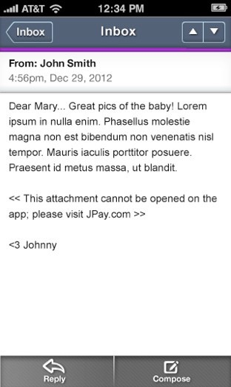

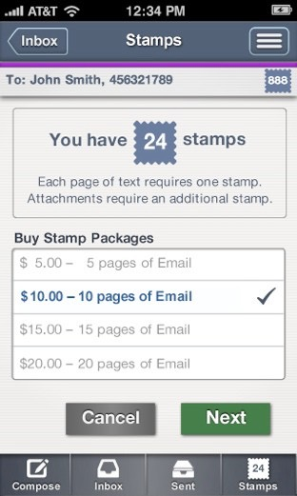 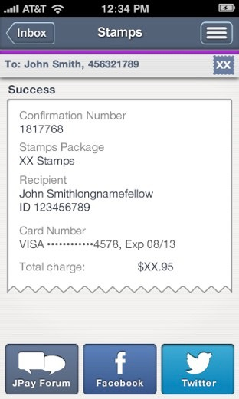

JPay Inmate Kiosk JP3 UI, Buy JP3 player (for inmates)

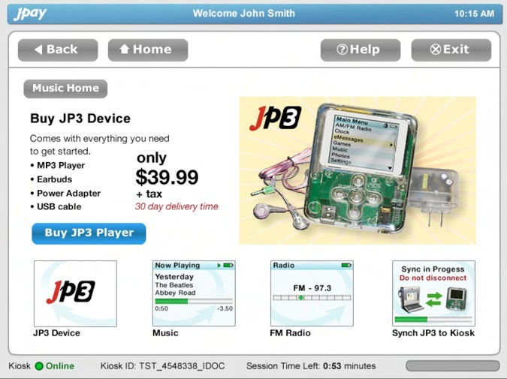

JPay Inmate Kiosk JP3 UI

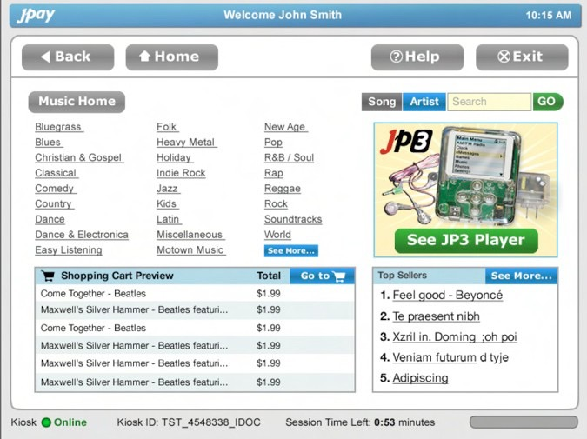

JPay Inmate Kiosk JP3 UI, top albums

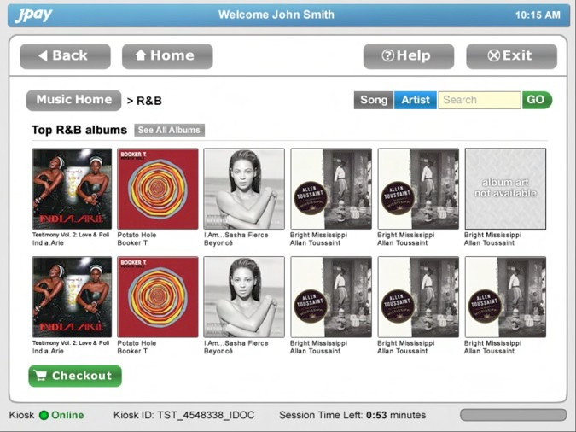

JPay Inmate Kiosk JP3 UI, Song listing

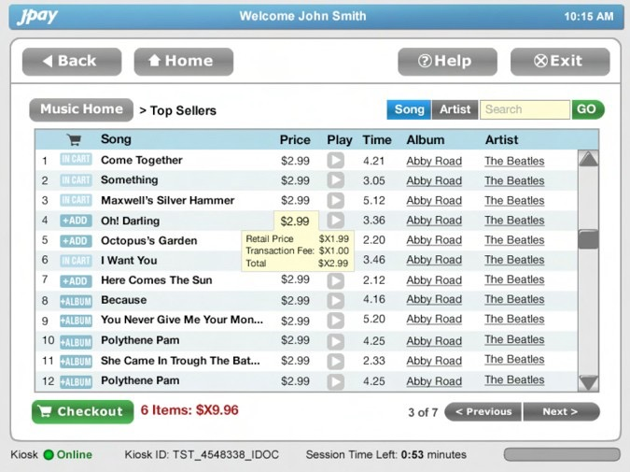

JPay Inmate Kiosk, Email

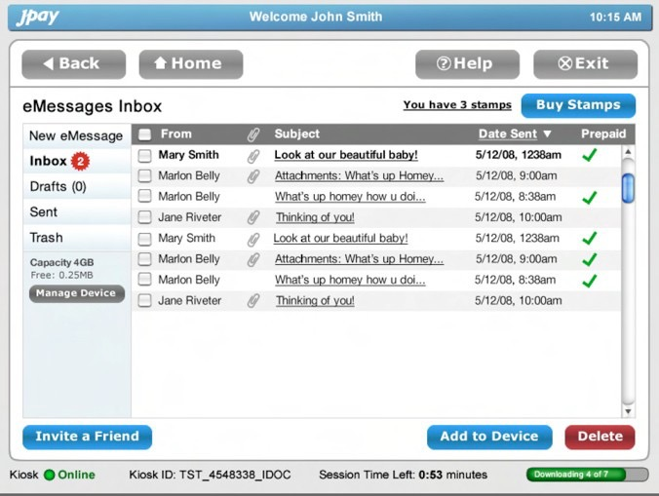

JPay Inmate Kiosk, Email composing

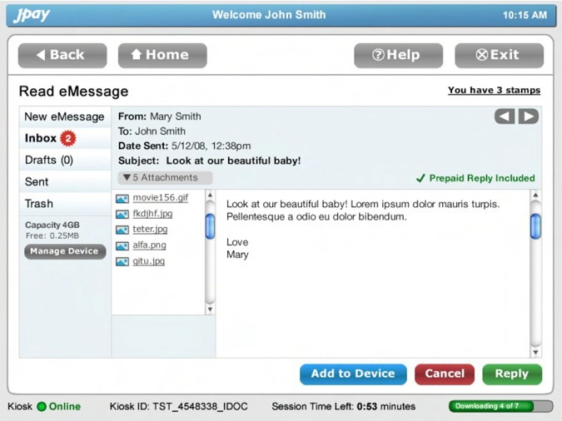

JPay Inmate Kiosk, Email, view photo

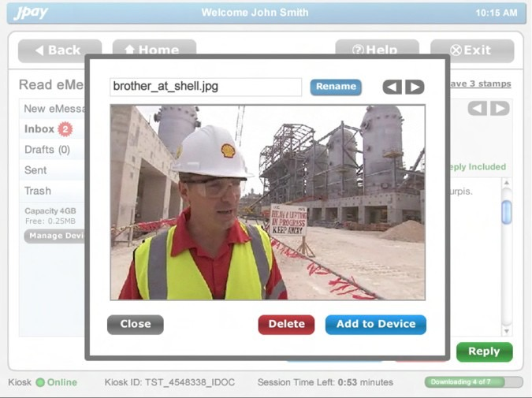

JPay Inmate Kiosk, Music, downloading music

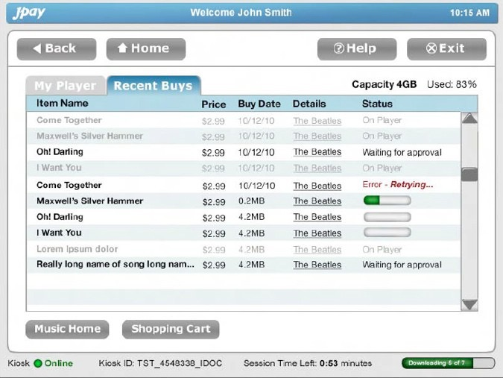

JPay Email

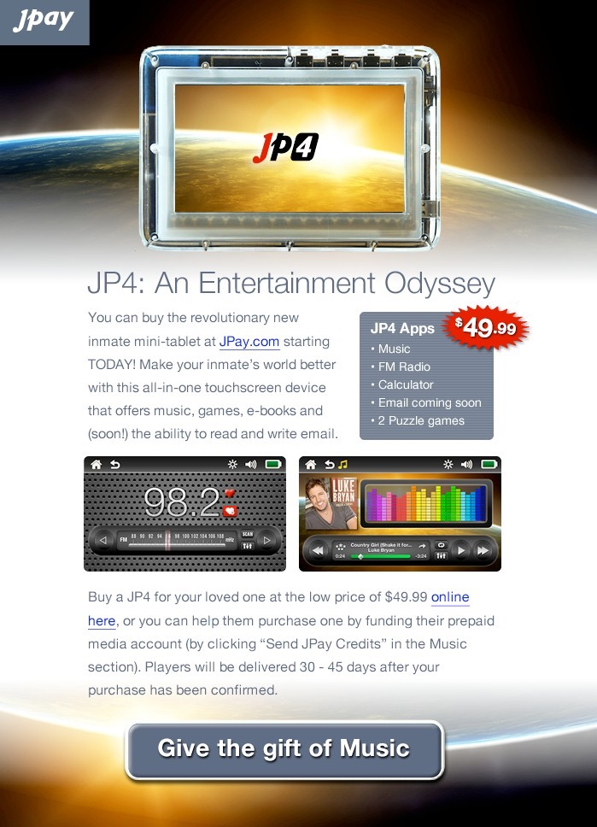

JPay Email

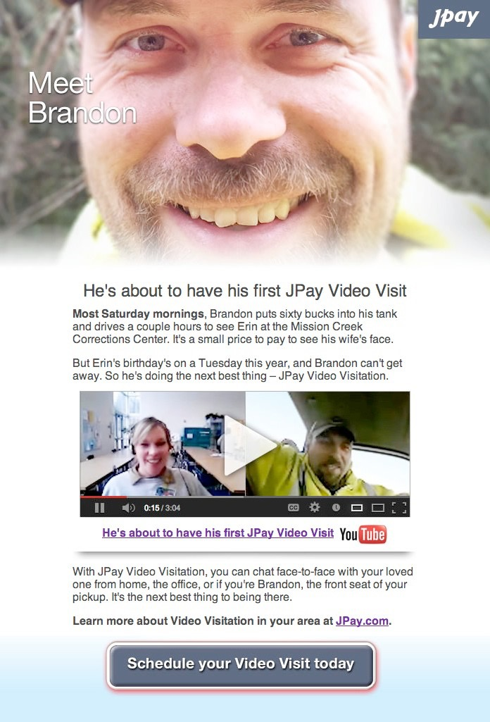

mLotto logo



mLotto app UI

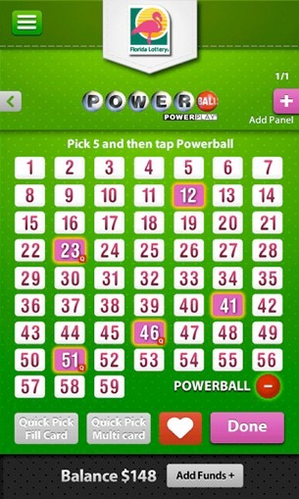 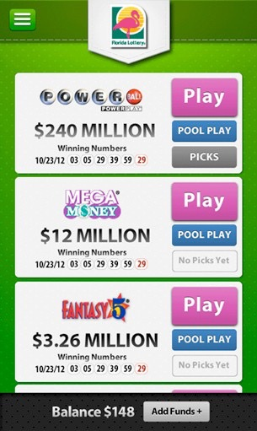

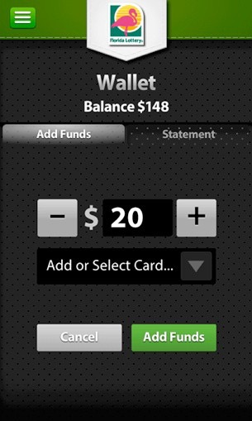 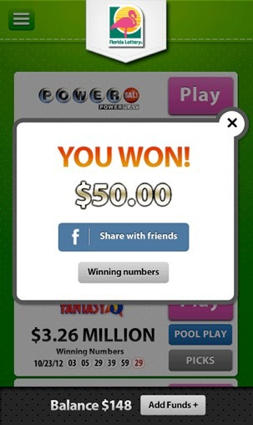 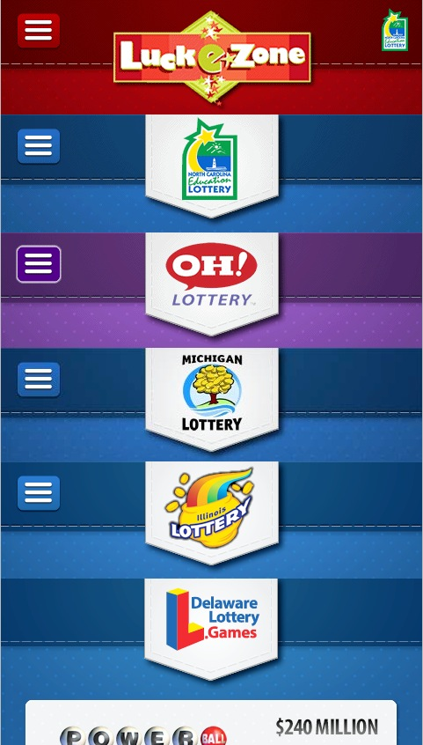

mLotto website

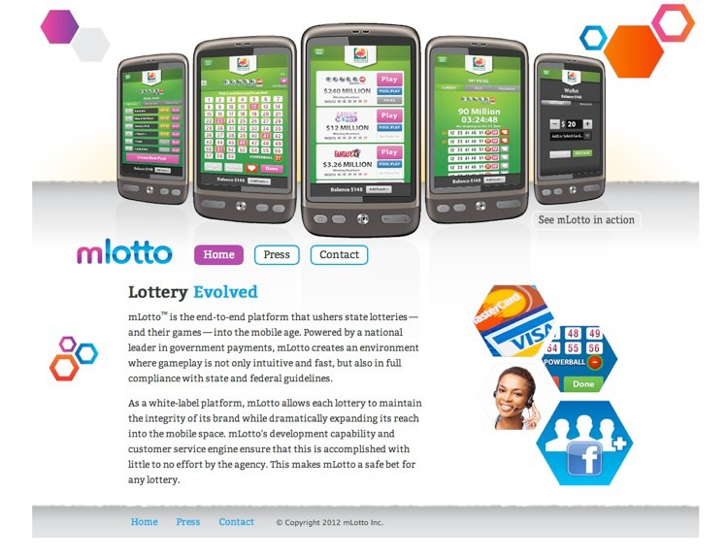

mLotto Brochure spread

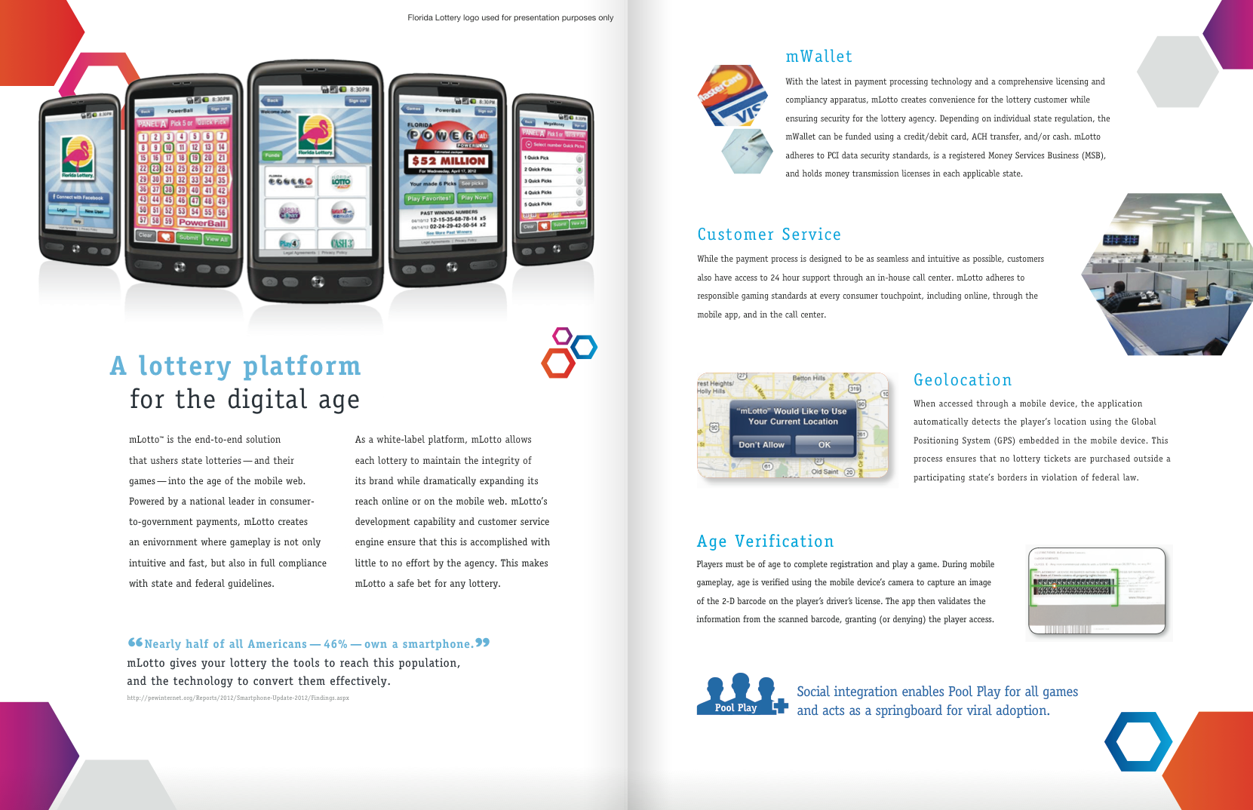

JPayInc.com website

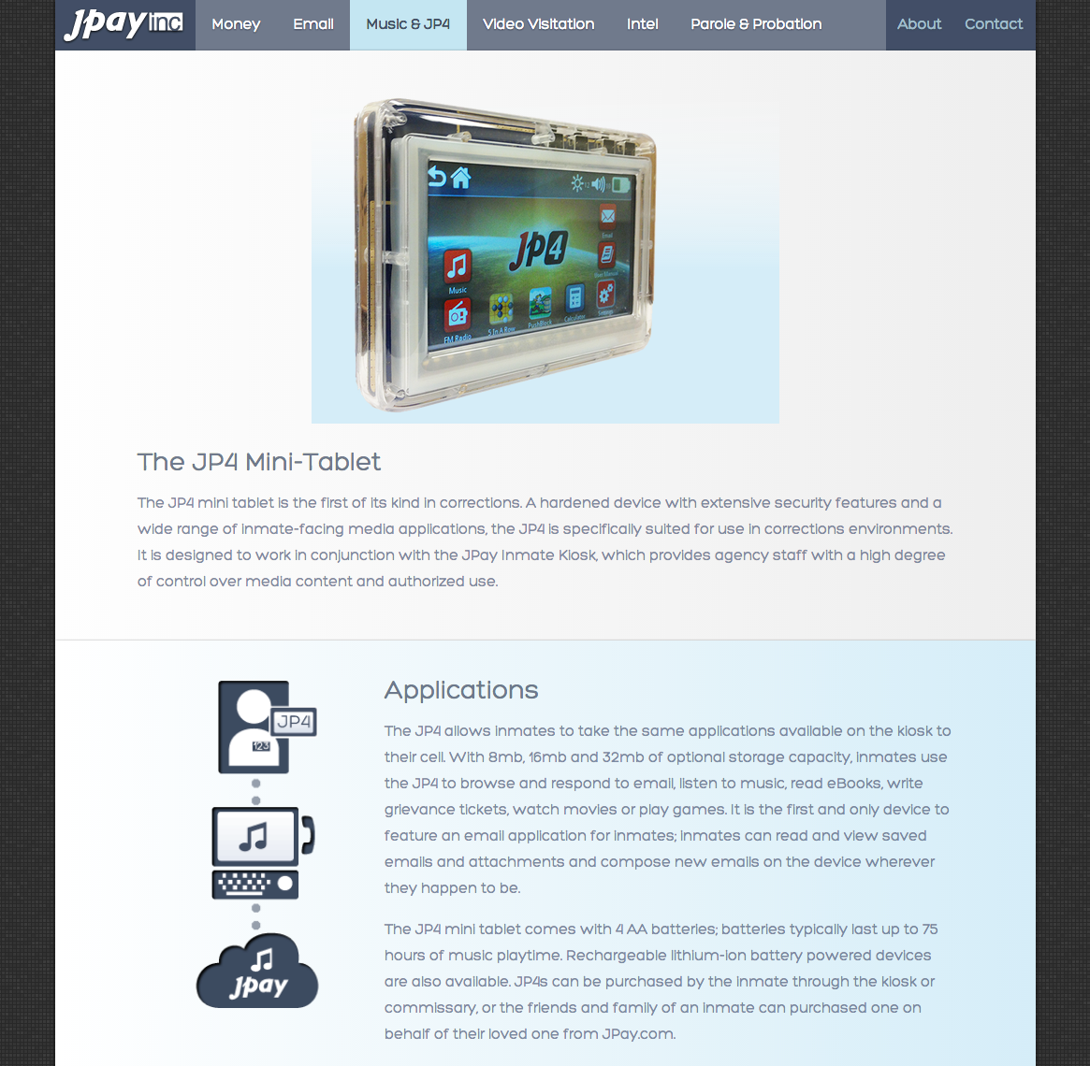 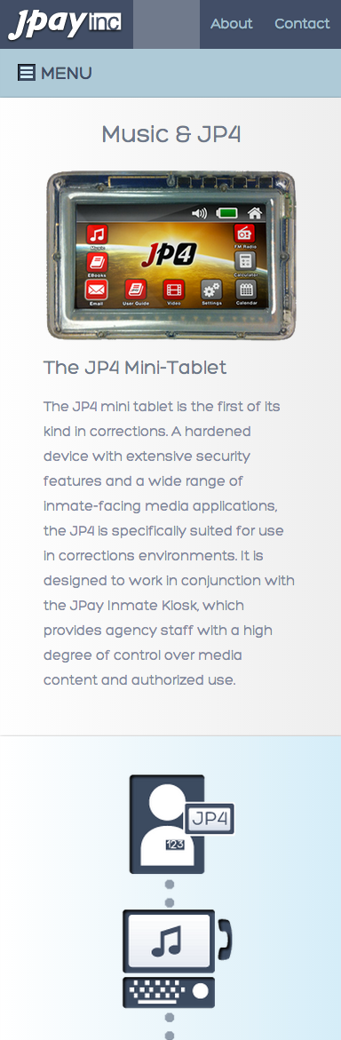

JPay Infographics

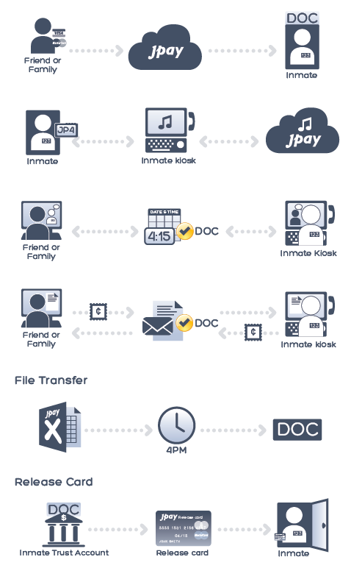

JPay app logo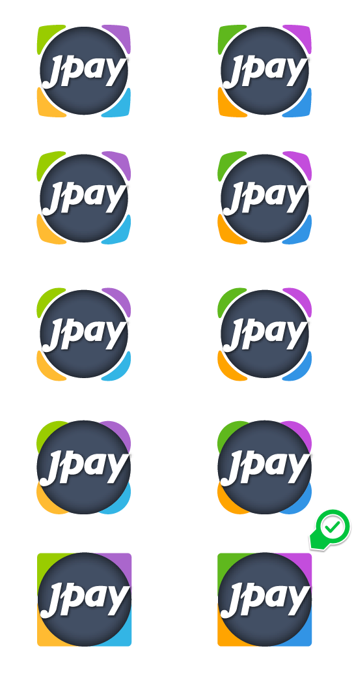

JPay Playing Card Designs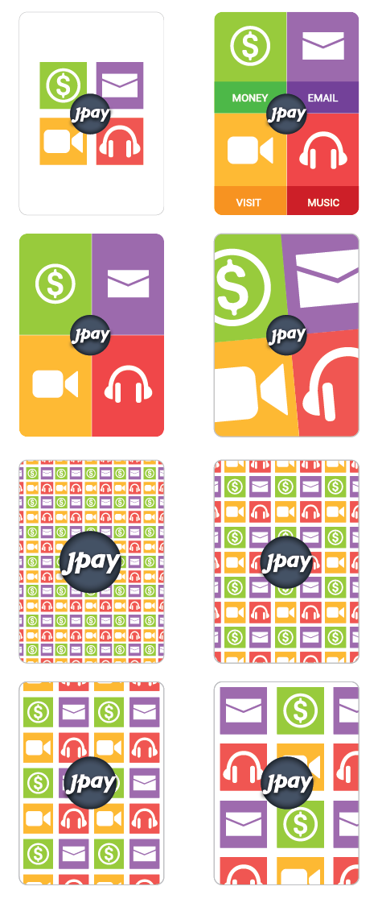

JPay front entrance wall mural

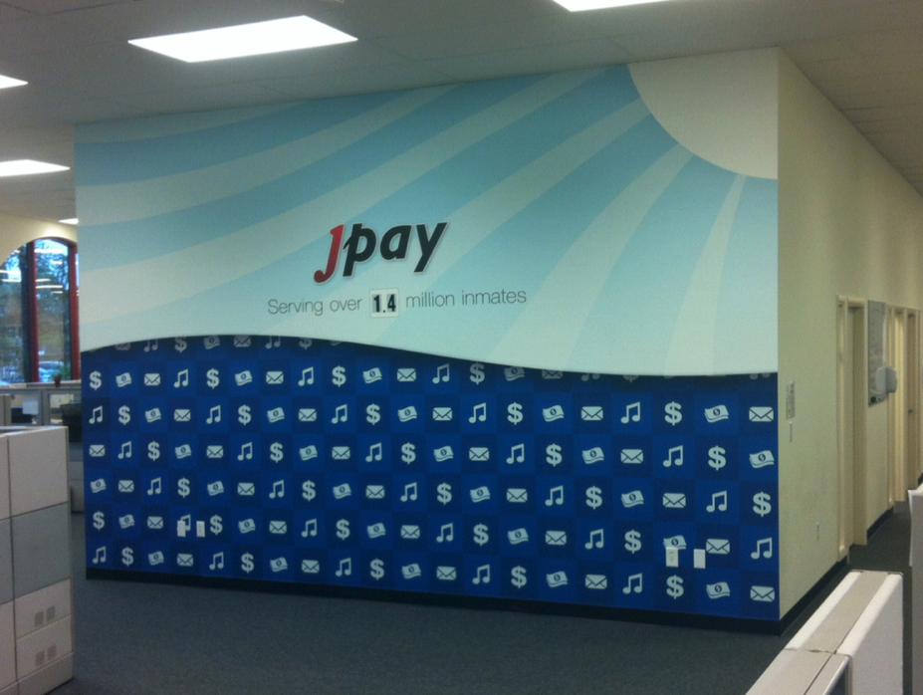

PrisonRide.com website

